**Challenge 8A**

An early Christmas surprise



, key=)

Harry,   
  
I am so sorry we went into the Russian HQ last night without you, but the Station Chief wanted it to be his team that got the glory. I am really grateful to you for coming back and putting us on the right track though. The stolen file from Soviet Headquarters was, as you expected, encrypted with the Solitaire cipher. Fortunately the cipher clerk who managed the encryption was incredibly careless. I found a sheet of burnt paper in the bin which gave me a list of thirty-eight cards, and I am hoping that this is a large part of the key. It will still be hard to break, but may be not impossible, especially as the erased part was still intact. There may be another clue in that the page appears to have been torn from an economics text book I found on the desk. Anyway, I figure the chemists at Langley may help us to reconstruct the whole key given time, though I wouldn’t expect them to manage more than one card a day given how careful they will have to be not to destroy the document. It will take us a while to crack this, but maybe time is on our side. With Christmas things seem to be quiet, and I am hoping that within the next three weeks we may know precisely what the Soviets were trying to do here.   
  
Whatever the outcome I think it is clear that the future of Europe is not likely to be settled for a while. I hear rumours every day about shortages in the Soviet bloc and border controls are going up in places you wouldn’t expect to prevent large scale migration. There are problems in Greece and Turkey and divisions between the British and French, and the Brits are having real trouble paying off their war debts. Whether or not we crack the Reichsdoktor mystery I think there is going to be plenty for you to do. I know we had to work hard to persuade you to fly over, but we really do need you here. Even the Chief recognizes that, so if I can I want to persuade you to stay. Francois and I are being posted to Paris. Kind of a thank you for our work on this project. But I can’t go unless I know the Berlin station has someone I trust. Hope you’ll agree to take the job.   
  
Charlie.

**Challenge 8B**

As the Red Sun rises



, key=Capital, solitaire cipher)

As the Red Sun rises, the cracks will propagate   
  
Comrades, it is clear that the uneasy peace between the four powers is unlikely to persist. Churchill’s comments at Yalta made clear that the British refuse to face the future success of global communism and Truman’s speech in Congress yesterday, spelled out his new doctrine of support for governments striving to oppress the proletariat. Our immediate concern is to maintain our sphere of influence in the Balkan states and the eastern European countries. If we are to see a red sun rising over the west and to succeed in establishing an international communist society then our task is clear.   
  
We must create and propagate cracks between the allies. While the Americans and British share an irrational hatred of our politics they are also suspicious of one another, and both share a deep suspicion of their French collaborators. We must work to enhance this suspicion and drive a wedge between the allies so that they are unable to coordinate their work against us.   
  
There is a natural venue for this project in Berlin, where our allies are cheek to cheek and yet deeply divided. They have a common goal to identify Nazi war criminals, and to try them or to turn them, but the nuclear arms race in which they are all engaged is one which they would each like to win. I propose that we set a false trail designed to sow discord among them. We have placed agents in their headquarters who will be able to assist us in our misinformation campaign, which I call the Reichsdoktor campaign. We have invented a Nazi defector and a fictitious Nazi relocation programme which our agent will offer to sell to all three powers. With the right incentives they will find themselves bidding against one another for intelligence, and with the right misinformation they will each believe that their allies are working against them. With luck, before long, their intelligence sharing arrangements will break down and we will be well placed to increase our powerbase in our historic march westwards.   
Comrades, the future belongs to the Soviet Union. Let us work together to make that destiny history.

Tovarisch Viktor Nachal'nik Shpionov

Game of Patience?

On day 1

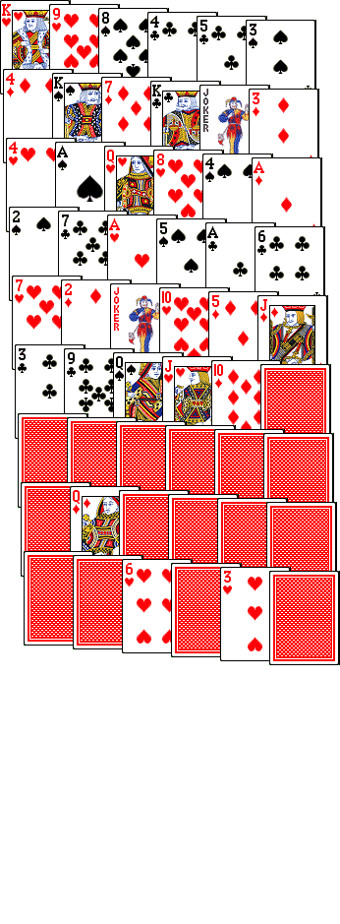

Day 4:

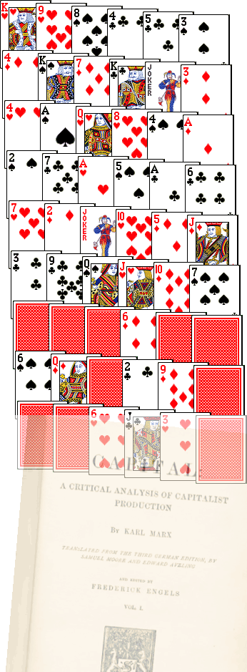

Day 6

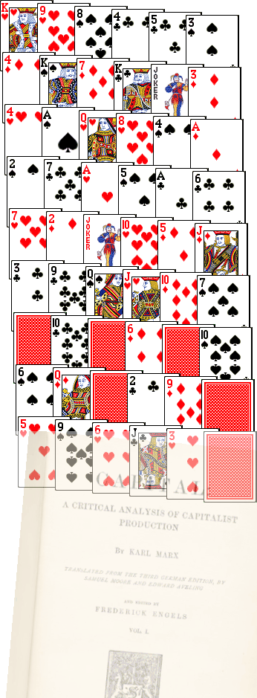

Final:

